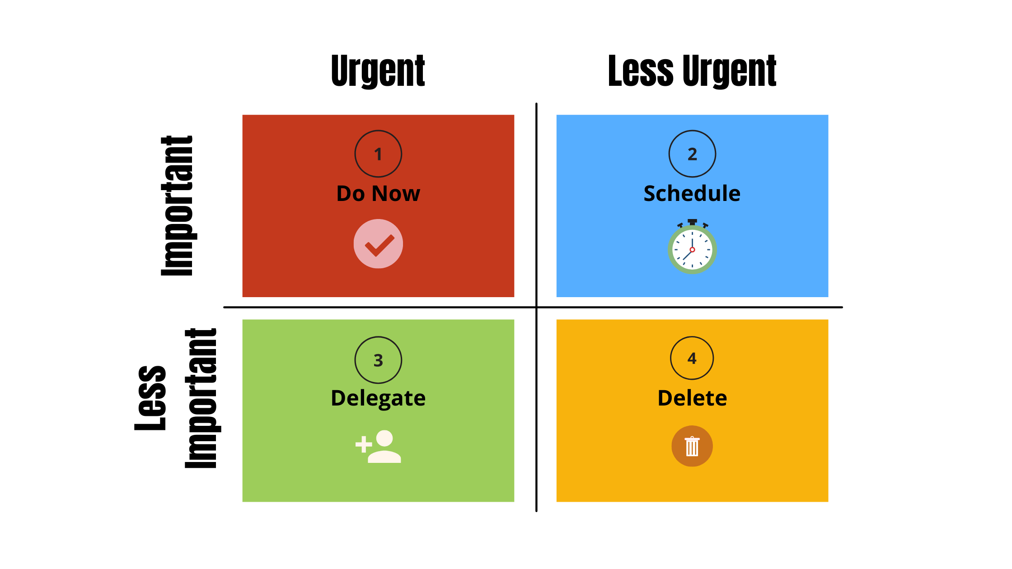 **Necessary Task**

* + **More important More Urgent**
  + **More important Less Urgent (A Time to Do It)**
  + **Less important (Add Someone) Less Urgent(Eliminate)**

**Mamunur Rashid (Mamun)**

**Software Department  
NR Group**